Urquhart Castle and the lords of the Isles – NoSAS 22/10/2013

Map showing the lands associated with the lordship of the Isles, and the earldom of Ross circa 1400s

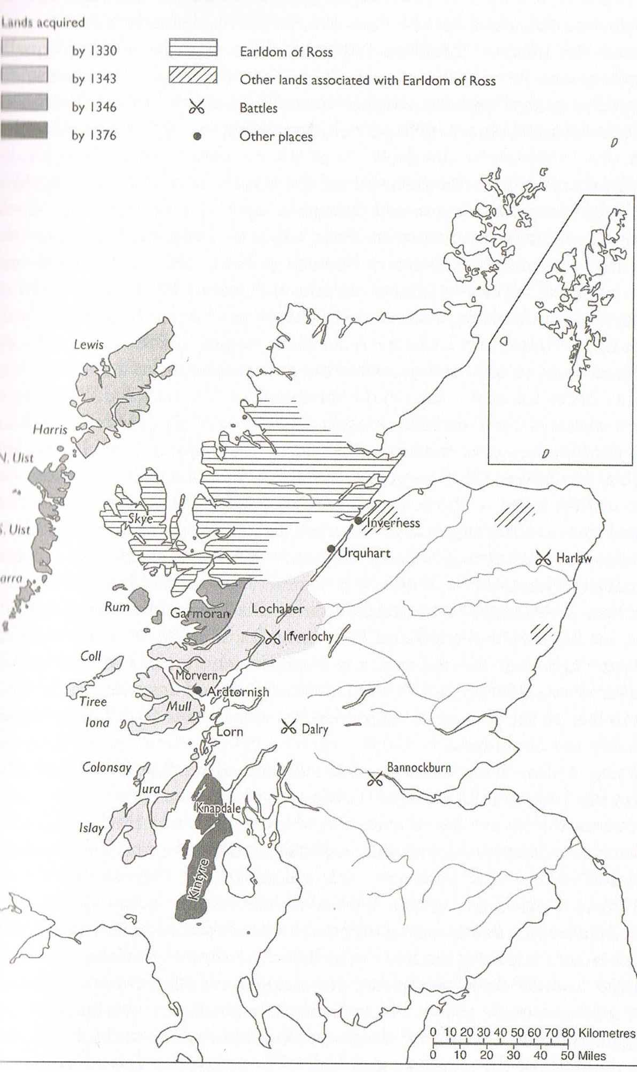

Taken from R. A. McDonald, ‘The Western Gaidhealtachd in the Middle Ages’ in B. Harris and A. R. MacDonald (eds.) Scotland: The Making and Unmaking of a Nation (Dundee, 2006), p. 81.
Map showing the ‘Highland Line’ circa 1400s

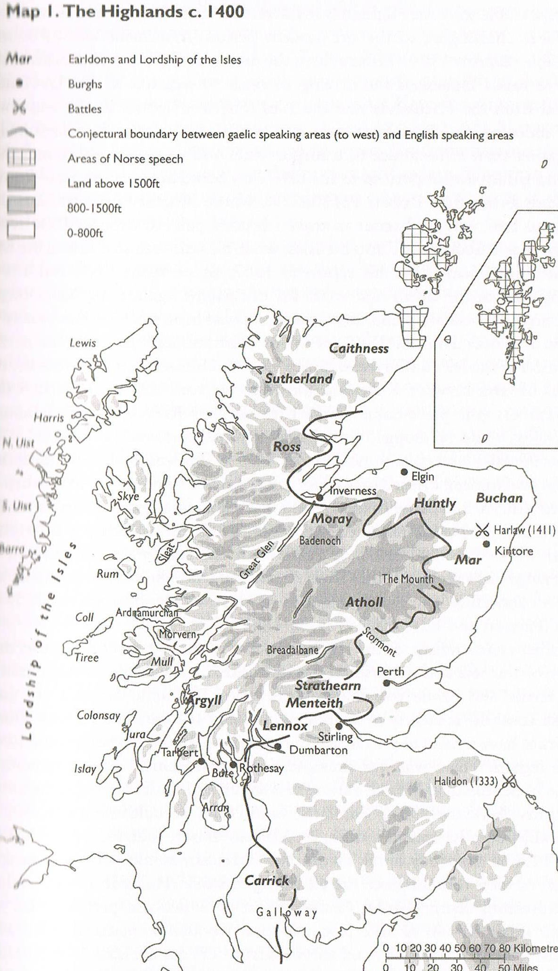

Taken from R. A. McDonald, ‘The Western Gaidhealtachd in the Middle Ages’ in B. Harris and A. R. MacDonald (eds.) Scotland: The Making and Unmaking of a Nation (Dundee, 2006), p. 67.

Genealogy of the lords of the Isles and earls of Ross (Fifteenth century)
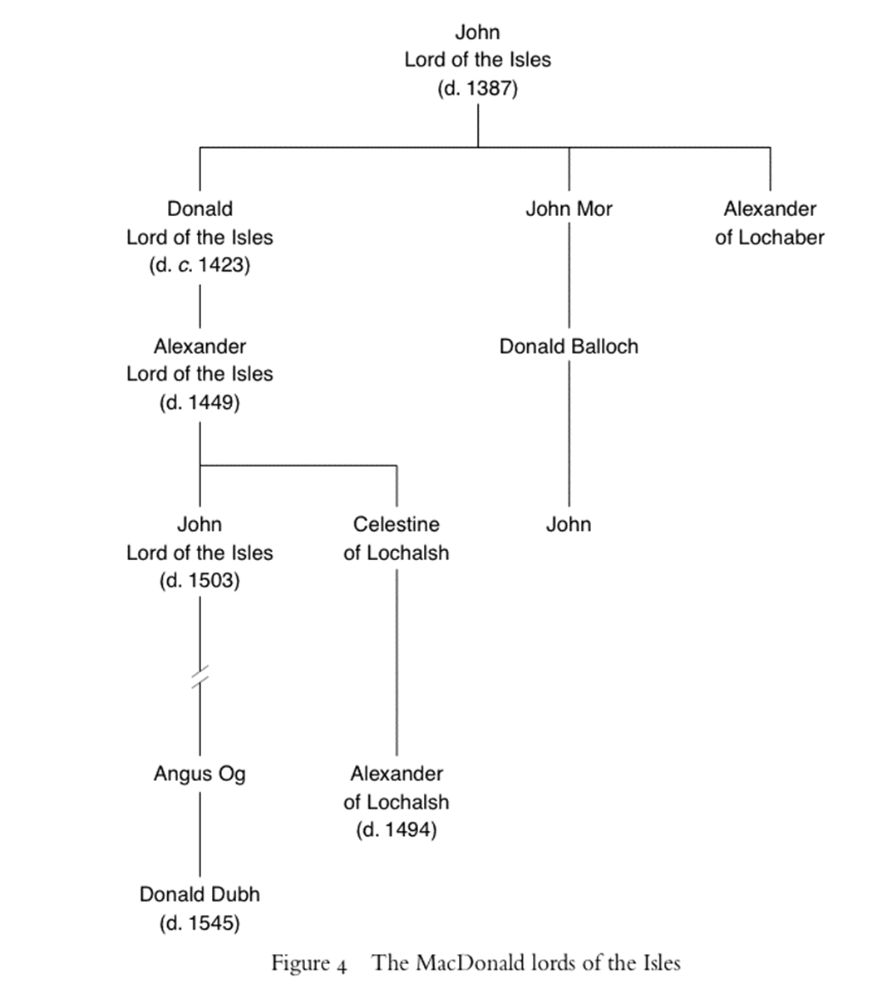
& earl of Ross
& earl of Ross until 1476

Bibliography

Primary Sources

Ane Breve Cronicle of the Earlis of Ross (Edinburgh: T. Constable, 1850).

Bain, J. (ed.) Calendar of Documents Relating to Scotland: Volume 4 1357-1509 (Edinburgh: Her Majesty’s General Registers House, 1888).

Balfour-Paul, J., (ed.) Registrum Magni Sigilli Regum Scotorum: The Register of the Great Seal of Scotland: A. D. 1424-1513: Volume II (Edinburgh: Her Majesty’s General Registers House, 1882).

Bliss, W. H. and Twemlow, J. A. (eds.) Calendar of Entries in the Papal Registers Relating to Great Britain and Ireland: Papal Letters A. D. 1362-1404 : Volume IV (London: His Majesty’s Stationers Office, 1902).

Bower, W., Scotichronicon: Volume VIII (ed.) D. E. R. Watt (Aberdeen: Aberdeen University Press, 1987).

Brewer, J. S. and Bullen, W., (eds.) Calendar of the Carlew Manuscripts: Volume VI (London: Longman and Co. and Trubner and Co., 1871).

Brown, K. M., (et. al. eds.) The Records of the Parliaments of Scotland to 1707 (St. Andrews: St Andrews University, 2007-2013). [online]
Available at <www.rps.ac.uk> Accessed 29th June 2013.

Calendar of the Patent Rolls Preserved in the Public Office Records [Hereafter ‘Patent Rolls’]: Richard II A. D. 1385-1389 (London: Her Majesty’s Stationary Office [Hereafter HMSO], 1900).
Patent Rolls: Edward IV A. D. 1461-1467 (London: HMSO, 1897).

Cameron, A, Reliquiae Celticae: Texts, Papers and Studies in Gaelic Literature and Philology: Volume II (Inverness: The Northern Counties Newspaper and Printing and Publishing Company Ltd., 1894).

Donaldson, G., (ed.) ‘1462 Treaty of Westminster-Ardtornish’ in Scottish Historical Documents (Edinburgh: Scottish Academic Press, 1974).

Iona Club (eds.) Colectanea De Rebus Albanicis Consisting of Original Papers and Documents Relating to the History of the Highlands and Islands of Scotland (Edinburgh: Thomas G. Stevenson, 1857).

MacPhail, J. R. N., Highland Papers: Volume I (Edinburgh: Edinburgh University Press, 1914).

MacPhail, J. R. N., Highland Papers: Volume III (Edinburgh: Edinburgh University Press, 1920).

Martin, M., A Description of the Western Islands of Scotland Circa 1695 (Edinburgh: Birlinn, 1999).

McLauchlan, T., (ed.) The Dean of Lismore’s Book: A Selection of Ancient Gaelic Poetry (Edinburgh: Edmonston and Douglas, 1862).

Monroe, D., ‘A Description of the Occidental i.e. Western Islands of Scotland’ in M. Martin, A Description of the Western Islands of Scotland Circa 1695 (Edinburgh: Birlinn, 1999).

Munro, J. and Munro, R. W., (eds.) Acts of the Lords of the Isles 1336-1493 (Edinburgh: Scottish History Society, 1986).

‘Papers of the Munro Family of Foulis’ in National Records of Scotland [online]
Available at < http://www.nas.gov.uk/onlineCatalogue/> Accessed 25th July 2013.

Stewart, W., The Bulk of the Chroniclis of Scotland or a Metrical Version of the History of Hector Boece: Volume III, W. Turnbull (ed.) (London: Longman, Brown, Green, Longmans and Roberts, 1858).

Thomson, T., (ed.) The Auchenleck Chronicle: Ane Schort Memoriale of the Scottis Cornikils for Addicioun (Edinburgh: Printed for Private Circulation, 1819).

Twemlow, J. A. (ed.) Calendar of Entries in the Papal Registers Relating to Great Britain and Ireland: Papal Letters [Hereafter ‘Papal Registers’] A. D. 1417-1431: Volume VII (London: HMSO, 1906).
Papal Registers A. D. 1427-1447: Volume VIII (London: HMSO, 1909).
Papal Registers A. D. 1431-1447: Volume IX (London, HMSO, 1912).
Papal Registers A. D. 1455-1464: Volume XI (London: HMSO, 1921).
Papal Registers A. D. 1458-1471: Volume XII (London: HMSO, 1933).
Papal Registers A. D. 1471-1484: Volume XIII Part 1 (London: HMSO, 1955).

Secondary Sources

Armit, I., The Archaeology of Skye and the Western Isles (Edinburgh: Edinburgh University Press, 1996).

Alston, D., Ross and Cromarty: A Historical Guide (Edinburgh: Birlinn, 1999).

Bannerman, J, ‘The Lordship of the Isles’ in J. M. Brown (ed.) Scottish Society in the Fifteenth Century (London: Edward Arnold, 1977).

Barrell, A. D. M., Medieval Scotland (Cambridge: Cambridge University Press, 2000).

Boardman, S. I., ‘”Pillars of the Community”; Clan Campbell and architectural patronage in the fifteenth century’, in R. D. Oram and G. P. Stell (eds.) Lordship and architecture in medieval and renaissance Scotland (Edinburgh: Birlinn, 2005).

Boardman, S. I., ‘Robert II (1390-1406) in M. Brown and R. Tanner (eds.) Scottish Kingship 1306-1542: Essays in Honour of Norman MacDougall (Edinburgh: Birlinn, 2008).

Bridgland, N., Urquhart Castle and the Great Glen (Edinburgh: Batsford/Historic Scotland, 2005).
Brown, J. M., ‘Taming the Magnates?’ in G. Menzies (ed.) The Scottish Nation (London: British Broadcasting Corporation, 1972).
Brown, M., James I (East Linton: Tuckwell Press, 2000).
Brown, M., ‘James I (1406-1437)’ in M. Brown and R. Tanner (eds.) Scottish Kingship 1306-1542: Essays in Honour of Norman MacDougall (Edinburgh: Birlinn, 2008).

Brown, M., ‘Regional lordship in north-east Scotland: the Badenoch Stewarts II: Alexandar Stewart, Earl of Mar’, Northern Scotland, Vol. 16 (1996).

Brown, M., ‘”Rejoice in the hear of Douglas”: The House of Douglas and the Presentation of Magnate Power in Late Medieval Scotland’, The Scotland Historical Review, Vol. 76 (2), No, 202 (1997).

Brown, M., ‘Stewart Monarchy 1371-1513’ in B. Harris and A. R. MacDonald (eds.) Scotland: The Making and Unmaking of a Nation Volume 1 (Dundee: Dundee University Press 2006).

Brown, M., Wars of Scotland 1214-1371 (Edinburgh: Edinburgh University Press, 2004).

Brydall, R., ‘The Monumental Effigies of Scotland, from the Thirteenth to the Fifteenth Century’, Proceedings of the Society of Antiquaries of Scotland, Vol. 29, 3rd Series (1894-5), pp. 329-410.

Buchanan. G., The History of Scotland: Volume II (Trans.) J. Aikman (Glasgow: Blackie, Fullerton and Co., 1827).

Caldwell, D. H. and Ruckley, N. A., ‘Domestic Architecture in the Lordship of the Isles’ in R. Oram and G. Stell (eds.), Lordship and Architecture in Medieval and Renaissance Scotland (Edinburgh: Birlinn, 2005).

Caldwell, D. H. and Ewart, G., ‘Finlaggan and the Lordship of the Isles: An Archaeological Approach, Scottish Historical Review, Vol. 72 (2), No. 194 (October 1993), pp. 146-166.

Caldwell, D. H., Islay: The Land of Lordship (Edinburgh: Birlinn, 2008).

Dodgshon, R. A., From Chiefs to Landlords (Edinburgh: Edinburgh University Press, 1998).

Dodgshon, R. A., ‘“Pretense of blude” and “place of their dwelling”: the nature of Highland clans, 1500-1745’ in R. Houston and I. Whyte (eds.) Scottish Society, 1500-1800 (Cambridge: Cambridge University Press, 2005).

Duncan A. A. M., Scotland: The Making of a Kingdom (Edinburgh: Mercat Press, 2000).

Foggie, J., ‘The Medieval Church’ in B. Harris and A. R. MacDonald (eds.) Scotland: The Making and Unmaking of a Nation: Volume 1 (Dundee: Dundee University Press, 2006).

Gillies, W., ‘The Red Book and Black Book of Clanranald’, Clan Donald Society Conference: The Legacy of the Lords of the Isles (Edinburgh: University of Edinburgh, 2006), [online].
Available at <http://www.ed.ac.uk/schools-departments/literatures-languages-cultures/celtic-scottish-studies/research-publications/research/internal-projects/clanranald> Accessed 16th April 2013.
Grant, A., ‘Crown and Nobility in Late Medieval Europe’ in R. N. Mason (ed.) Scotland and England 1286-1815 (Edinburgh: John Donald, 1987).
Grant, A., ‘Earls and earldoms in late medieval Scotland (c.1310-1460)’, in J. Bossy and P. Jupp (eds.) Essays presented to Michael Roberts, sometime professor of modern history in the Queen's University of Belfast (Belfast: Blackstaff Press, 1976).
Grant, A., Independence and Nationhood: Scotland 1306-1469 (Edinburgh: Edinburgh University Press, 2001).
Grant, A., ‘Scotland’s “Celtic Fringe” in the Late Middle Ages: The MacDonald Lords of the Isles and the Kingdom of Scotland’ in R. R. Davies (eds.) The British Isles 1100-1500: Comparisons, Contrasts and Collections (Edinburgh: John Donald, 1998).

Hunt, K, ‘The Governorship of Robert, Duke of Albany (1406-1420)’ in M. Brown and R. Tanner (eds.) Scottish Kingship 1306 – 1542: Essays in Honour of Norman MacDougall (Edinburgh: Birlinn, 2008).

Kingston, S., Ulster and the Isles in the Fifteenth Century: The Lordship of Clann Domhnaill of Antrim (Dublin: Four Courts Press, 2004).

Lynch, M., Scotland: A New History (London: Pimlico, 1998).

MacDonald, F. A., The Mission of the Gaels: Reformation and Counter-Reformation in Ulster and the Highlands and Islands of Scotland 1560-1760 (Edinburgh: Birlinn, 2006).

MacDougall, N., ‘Achillies’ heel? The earldom of Ross, the Lordship of the Isles, and the Stewart Kings 1449-1507’ in E. J. Cowan and R. A. McDonald (eds.) Alba: Celtic Scotland in the Middle Ages (East Linton: Tuckwell, 2000).

MacDougall, N., James III (Edinburgh: John Donald, 2009).

MacDougall, N., James IV (Edinburgh: John Donald, 2006).

MacKenzie, A. M., The Rise of the Stewarts (London: Alexander Mackehose & Co, 1935).

Marren, P., Grampian Battlefields: The Historic Battles of North East Scotland A.D. 84 to 1745 (Aberdeen: Aberdeen University Press, 1990).

McDonald, R. A., The Kingdom of the Isles: Scotland’s Western Seaboard c. 1100-1336 (East Linton: Tuckwell Press, 1998).

McDonald, R. A., ‘The Western Gailhealtachd in the Middle Ages’, in B. Harris and A. R. MacDonald (eds.) Scotland: The Making and Unmaking of a Nation: Volume 1 (Dundee: Dundee University Press, 2006).

McGladdery, C., James II: The Stewart Dynasty in Scotland (Edinburgh: John Donald, 1990).

McGladdery, C., ‘James II (1437-1460)’ in M. Brown and R. Tanner (eds.) Scottish Kingship 1306-1542: Essays in Honour of Norman MacDougall (Edinburgh: Birlinn, 2008).

Munro, J., ‘The Lordship of the Isles’ in L. MacLean (ed.), The Middle Ages in the Highlands (Inverness: Inverness Field Club, 1981).

Nicholson, R., Scotland: The Later Middle Ages (Edinburgh: Mercat Press, 1997).

Oram, R. D., ‘The Lordship of the Isles: 1336-1545’ in D. Ormand (ed.), The Argyll Book (Edinburgh: Birlinn, 2004).

Paterson, R. C., The Lords of the Isles: A History of Clan Donald (Edinburgh: Birlinn, 2001).

Pumpelly-Read, H., Rossiana: Papers and Documents relating to the History and Genealogy of the Ancient and Noble House of Ross (New York: Historical Society of New York, 1908).

Skene, W. F., Celtic Scotland: Volume III (Edinburgh: David Douglas, 1890).

Tanner, R., ‘James III (1460-1488)’ in M. Brown and R. Tanner (eds.) Scottish Kingship 1306-1542: Essays in Honour of Norman MacDougall (Edinburgh: Birlinn, 2008).

Thomson, O., The Great Feud: The Campbells and the MacDonalds (Shroud: Sutton Publishing, 2000).

Thomson, T., A History of the Scottish People from the Earliest Times: Volume II (London: Blackie & Son, 1893).

Whyte, I., ‘Rural Society and Economy’ in B. Harris and A. R. MacDonald (eds.) Scotland: The Making and Unmaking of a Nation: Volume 1 (Dundee: Dundee University Press, 2006).

